step 1 : open terminal
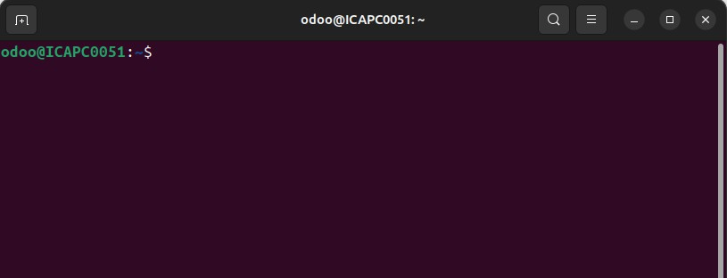
-- show like that

step 2 : install python version
you can install any python version here I will installing latest python virsion
code : sudo apt install python3.12-venv
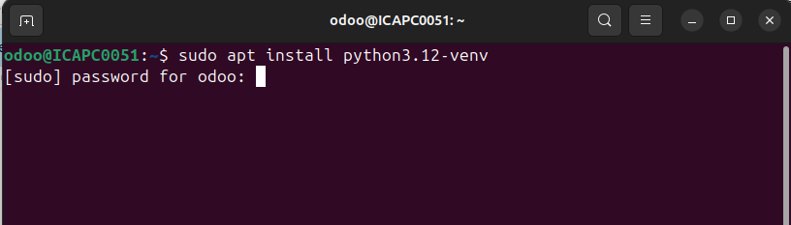
- after enter password you can see like that ,
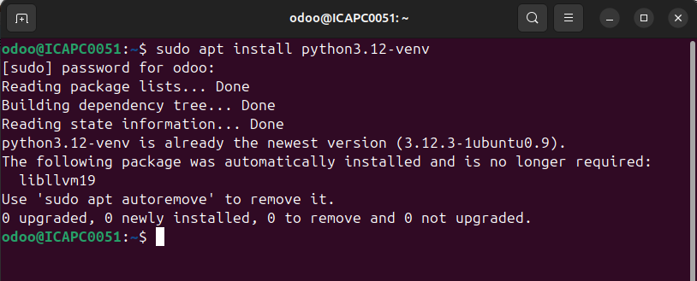

now,python3.12 version successfully created

step 3 : create virtual environment
code : python3 -m venv [virtual_environment_name]
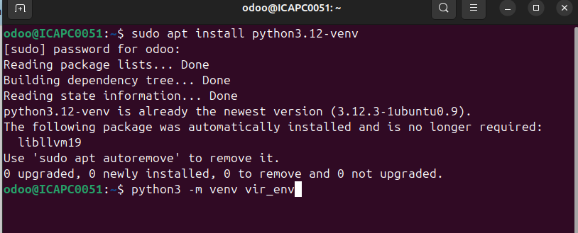
here, I have give a name as vir_env. you can give any name

step 4 : active the virtual environment
Before installing any packages, you must activate the environment.
code : source [virtual_environment_name]/bin/activate
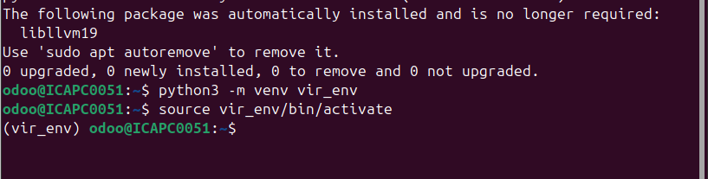
after activate, you can see like that and your virtual environment are activate

step 5 : install python libraries
Now you can able to install python libraries using this code : pip install [library_name]

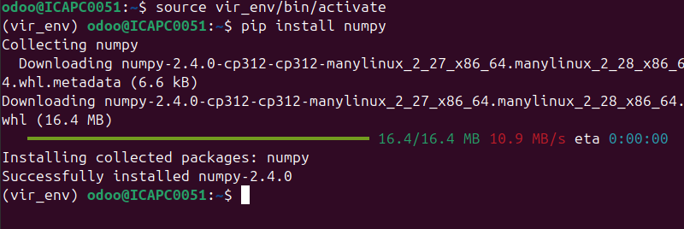
if you want to show all libraries use code : pip list
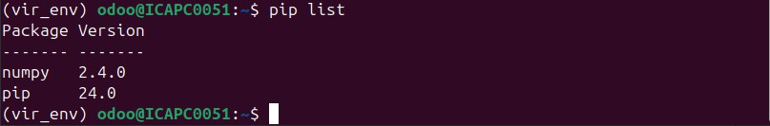
here, display all the libraries which you are installed

step 6 : Deactivate
code : deactivate
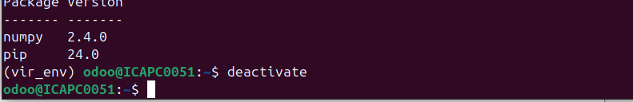
now you deactivate your virtual environment

